Maven :
Is used for project management and build management.
Why maven :
- It provides central repository for jars. (maven takes jars from its repository and put it in project. No need to do it manually. We just have to mention dependency(in pom.xml) and those jars will be automatically in project)
- Maintains common structure across the organization
- Flexibility to integrate with CI tools
- Plugins for test framework execution

Maven terminologies :
- Artifact : is a file, mainly JAR that gets deployed to maven repository
- GroupID : Will identify your project uniquely across all projects

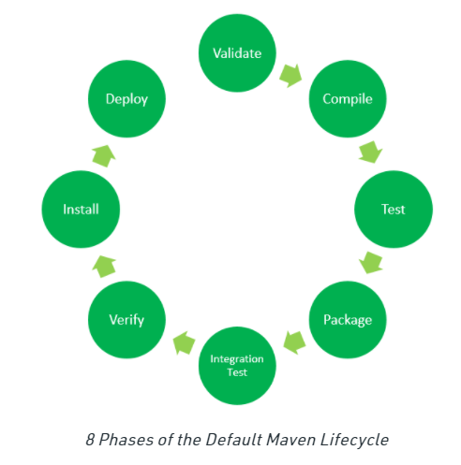
- Validate: This step validates if the project structure is correct. For example – It checks if all the dependencies have been downloaded and are available in the local repository.
- Compile: It compiles the source code, converts the .java files to .class and stores the classes in target/classes folder.
- Test: It runs unit tests for the project.
- Package: This step packages the compiled code in distributable format like JAR or WAR.
- Integration test: It runs the integration tests for the project.
- Verify: This step runs checks to verify that the project is valid and meets the quality standards.
- Install: This step installs the packaged code to the local Maven repository.
- Deploy: It copies the packaged code to the remote repository for sharing it with other developers.

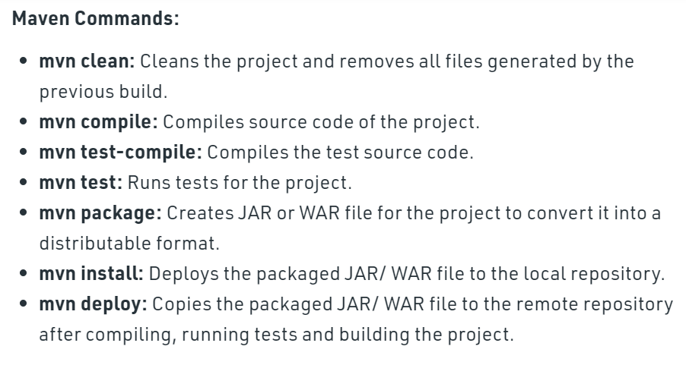
mvn clean install : tells Maven to do the clean phase in each module before running the install phase for each module.

